Creating RDS in AWS and Connect with my SQL work bench

1.Go to your Amazon account and search for RSD.
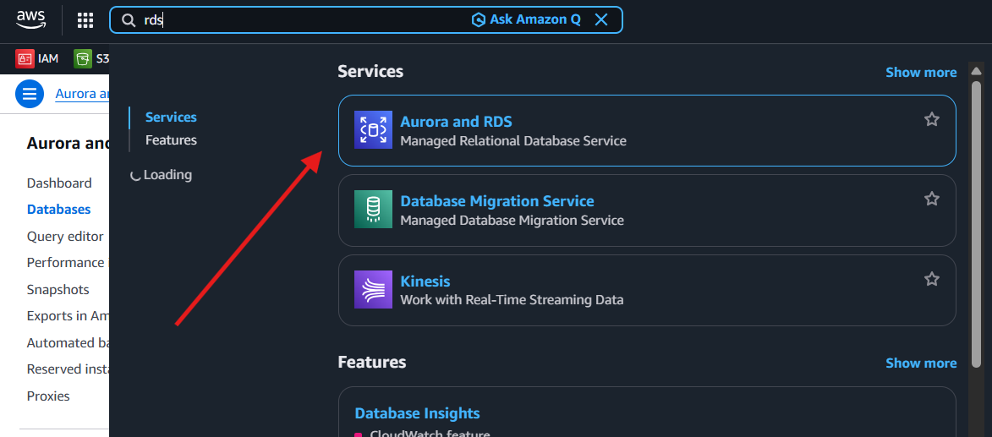
2. Go to the dashboard and open the DB instance.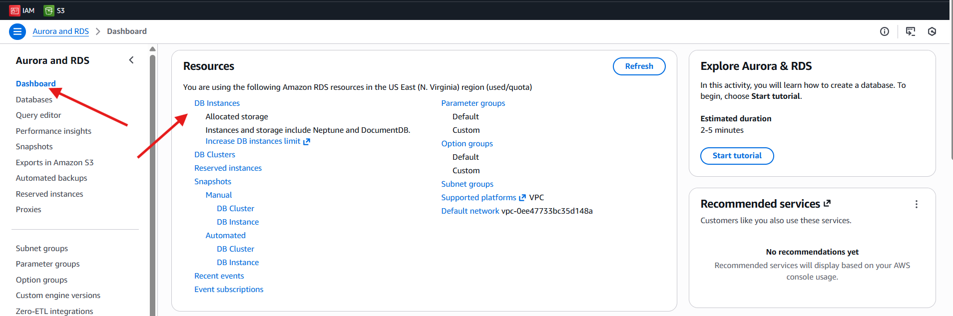
3. Choose “Create Database” to proceed.
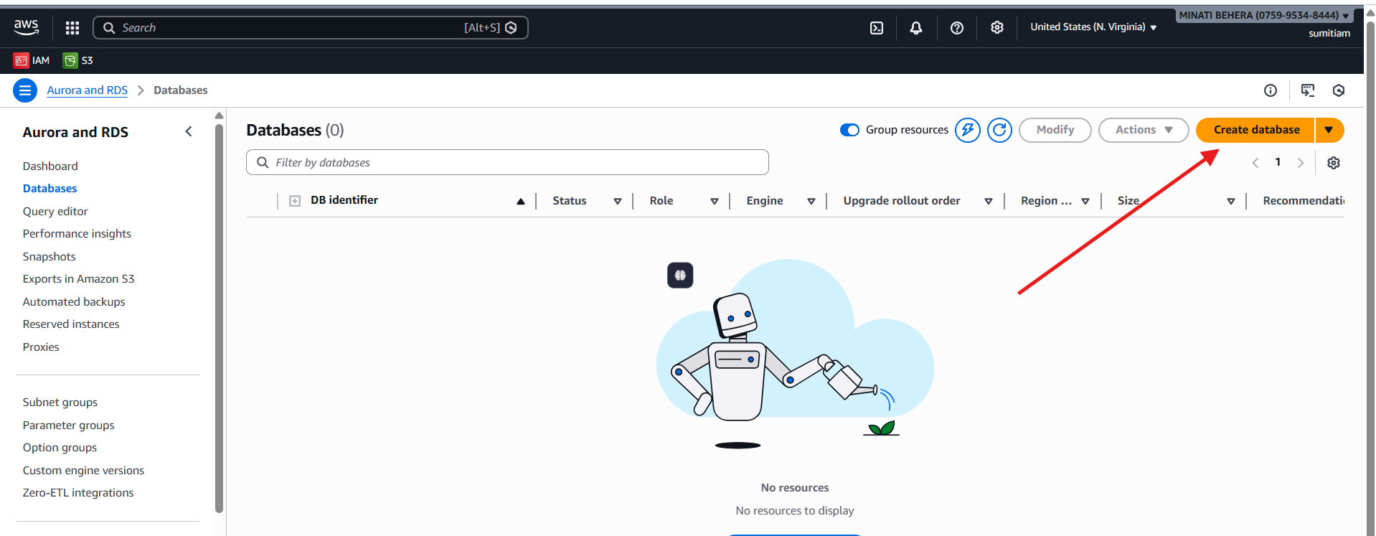

4. Select the preferred database creation method & Engine options
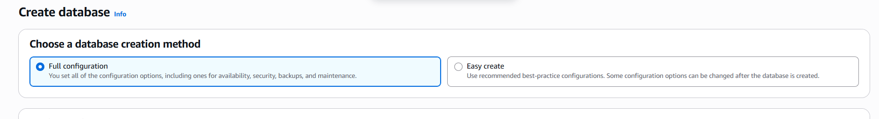
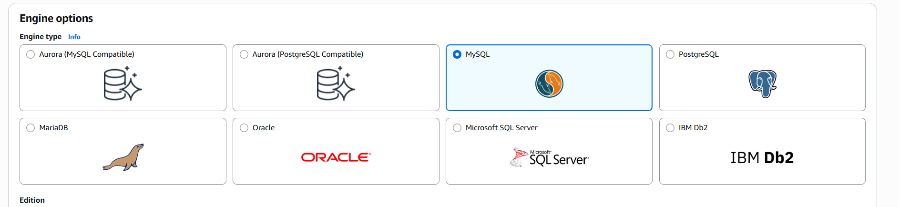
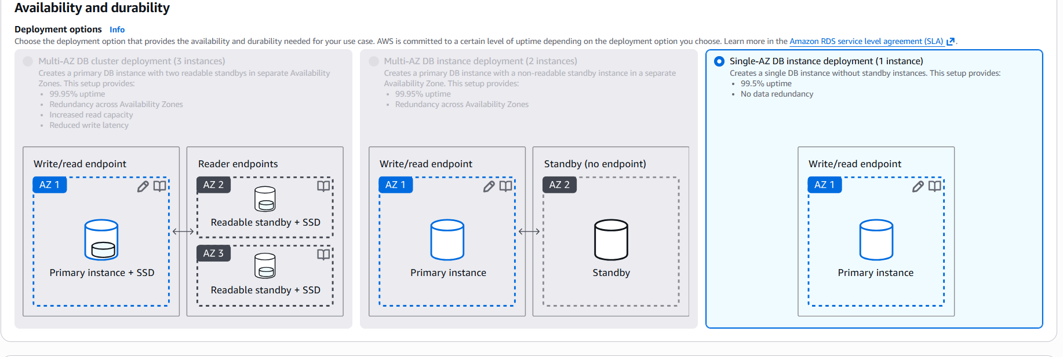
5. Enter the DB instance identifier and master user name
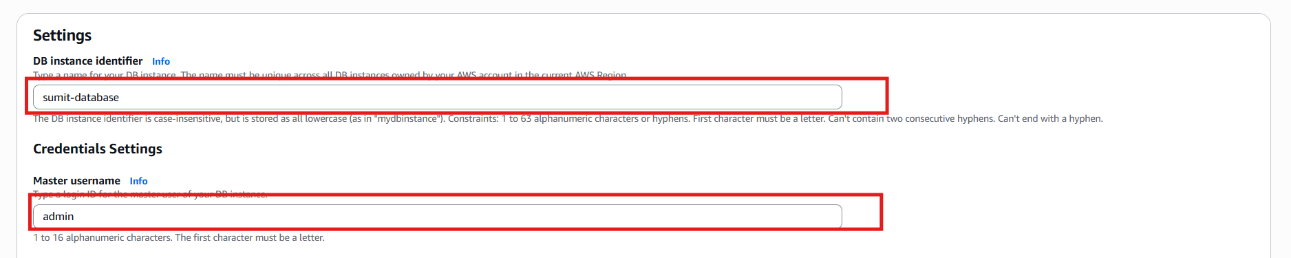
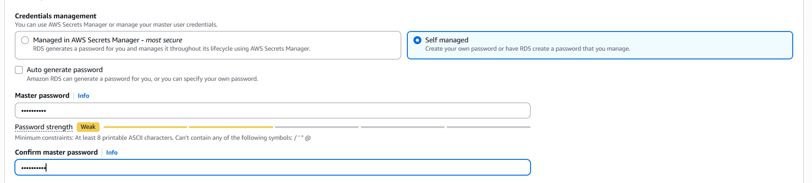
6.Make public access ‘Yes’
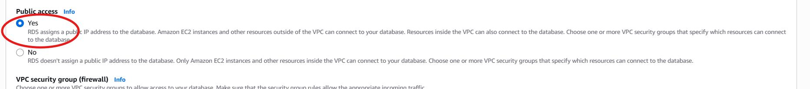

7. Choose “Create Database” to proceed.

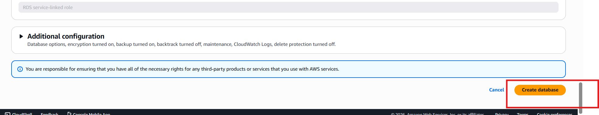
8. Click on the DB identifier that you created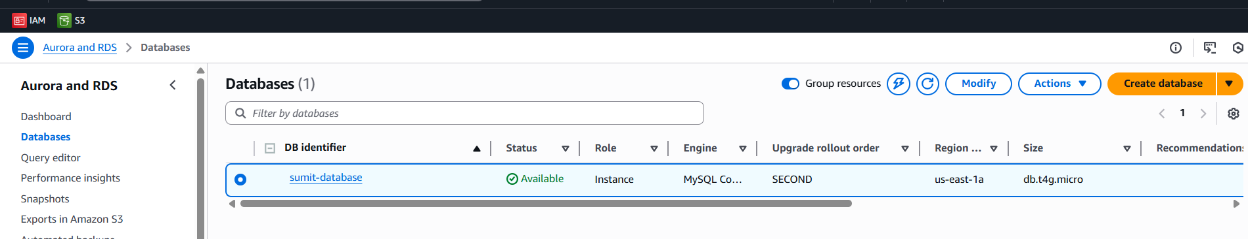
9.Go to Endpoints
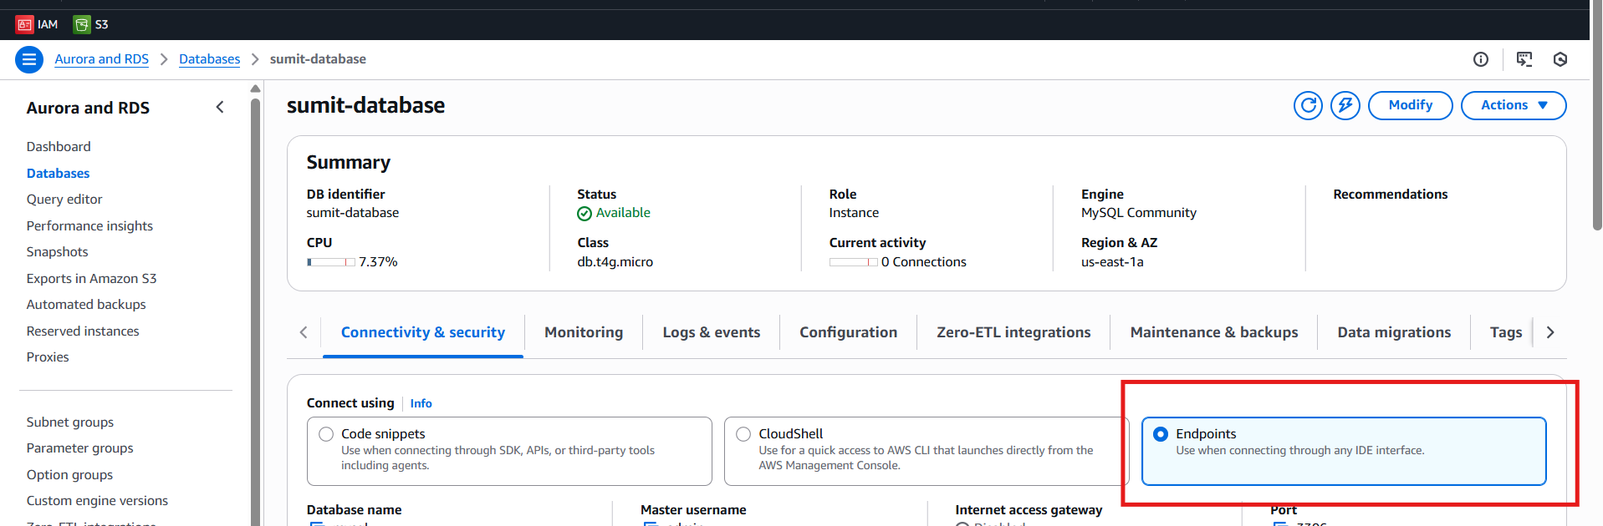
10.Go to VPC Security groups 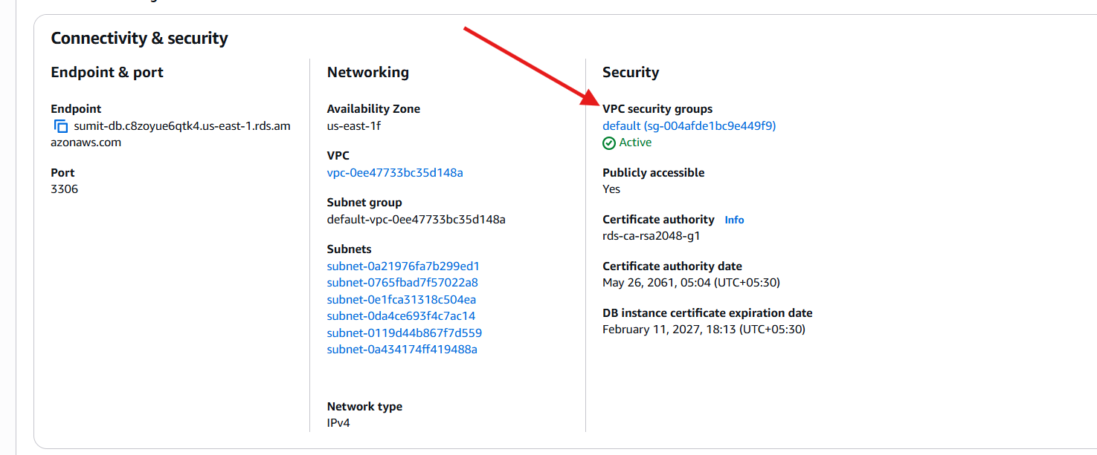

11. Click on Security group ID
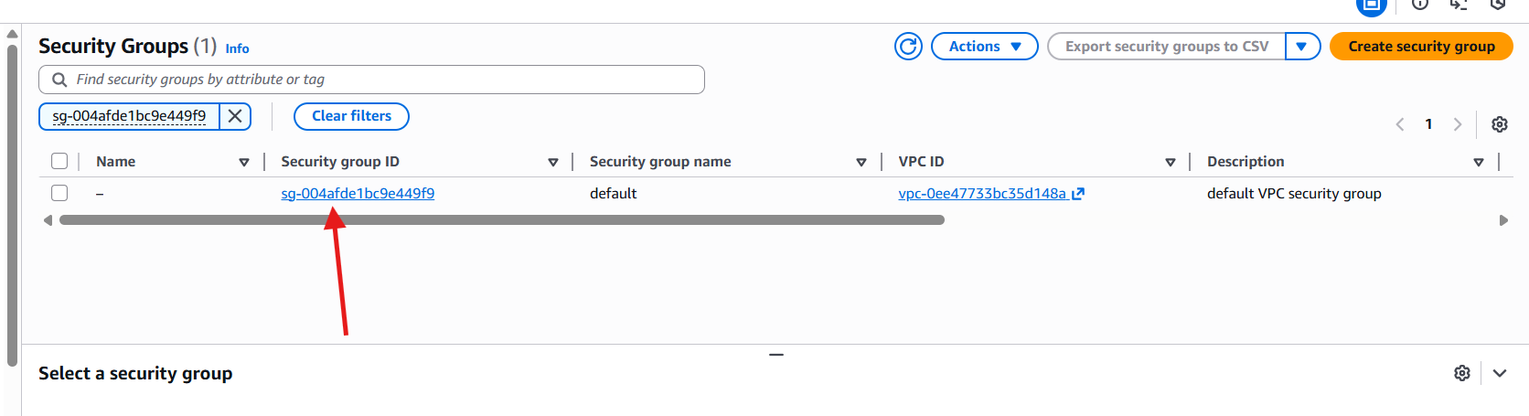
12.Edit inbound Rules
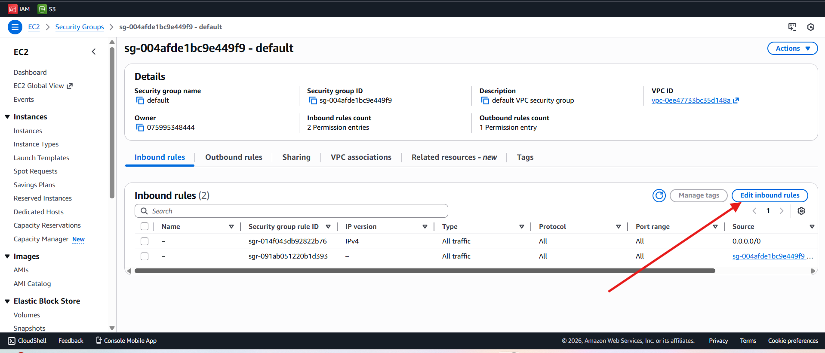
14.Edit the inbound rules and set source to ipv4
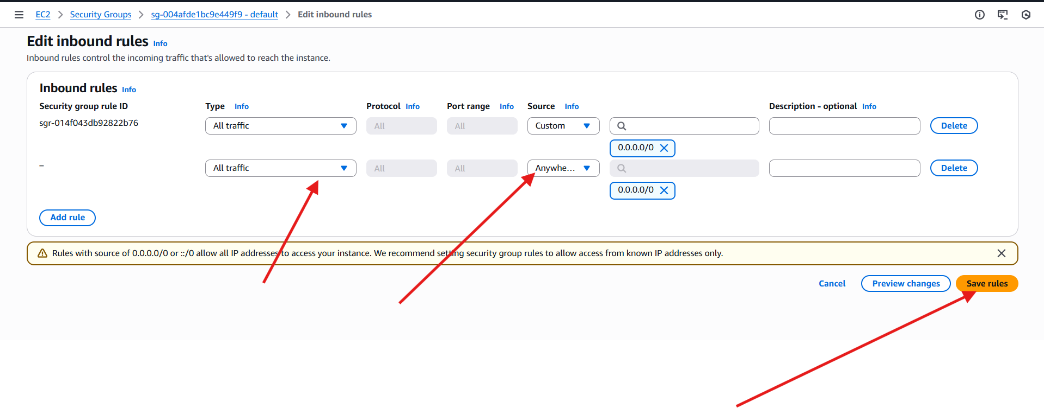

15.Copy the Endpoint URL
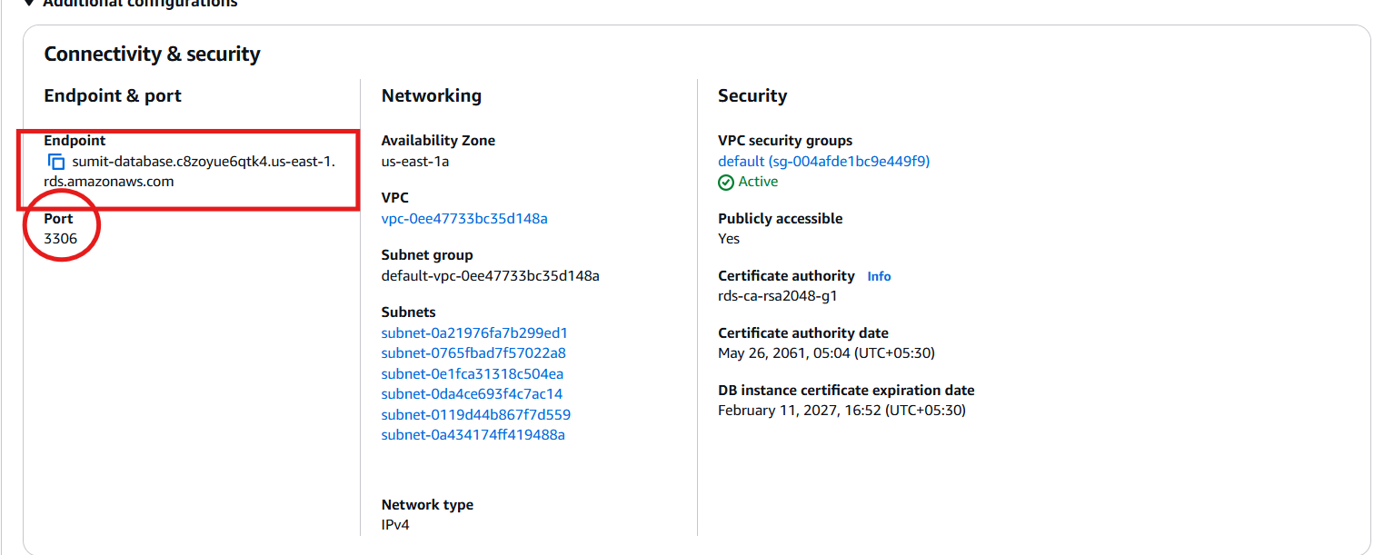

16.Open MySQL Workbench 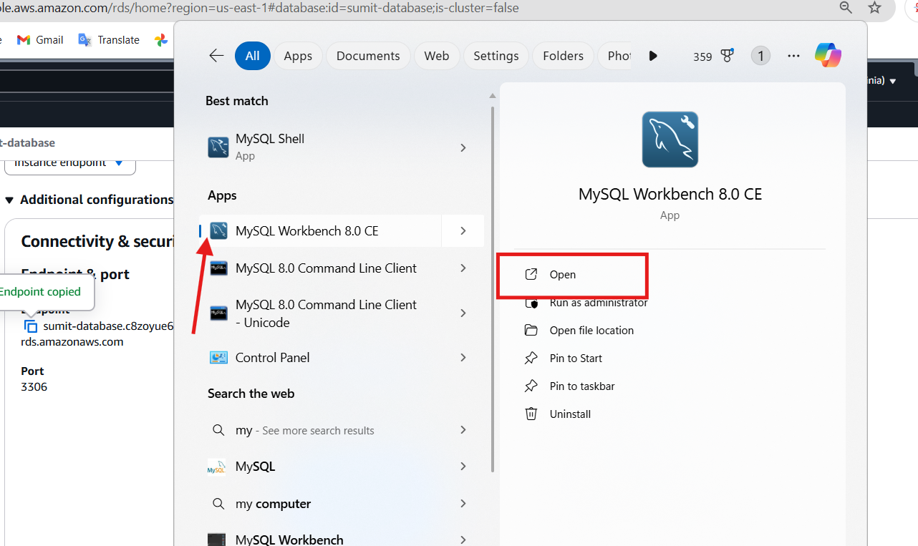

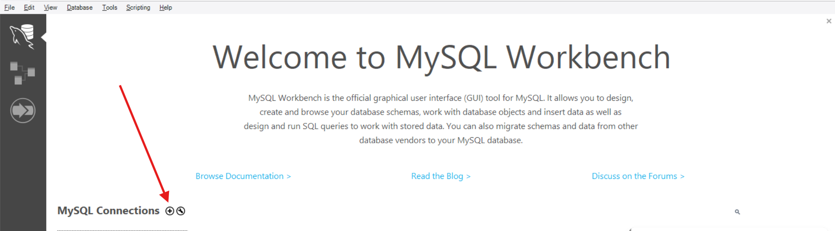
17. Enter the necessary requirements & click on Test Connection
(paste the End point url at Hostname)
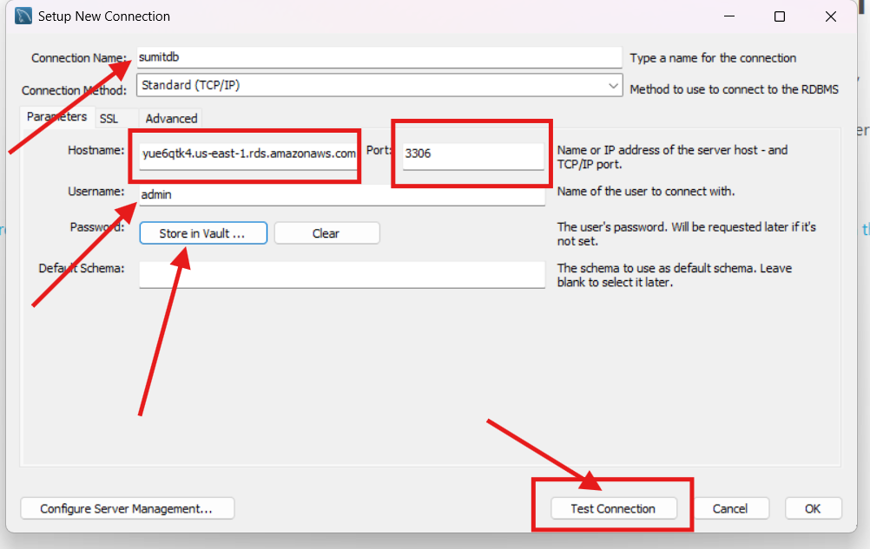
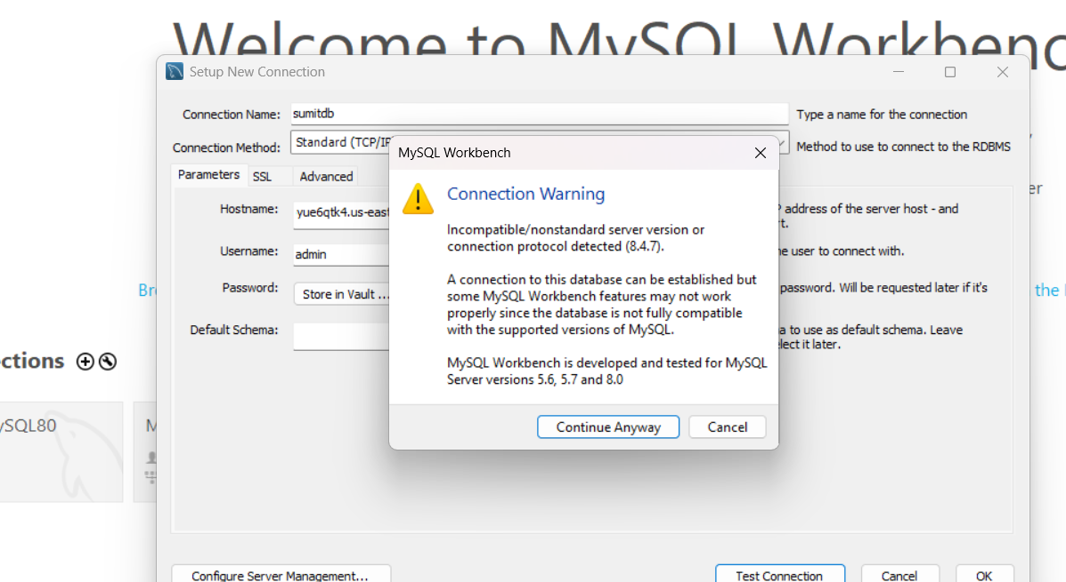

18. Successfully connected to MySQL. ✅

